**Parker House**

Website: <https://parker-house.com/>

#01

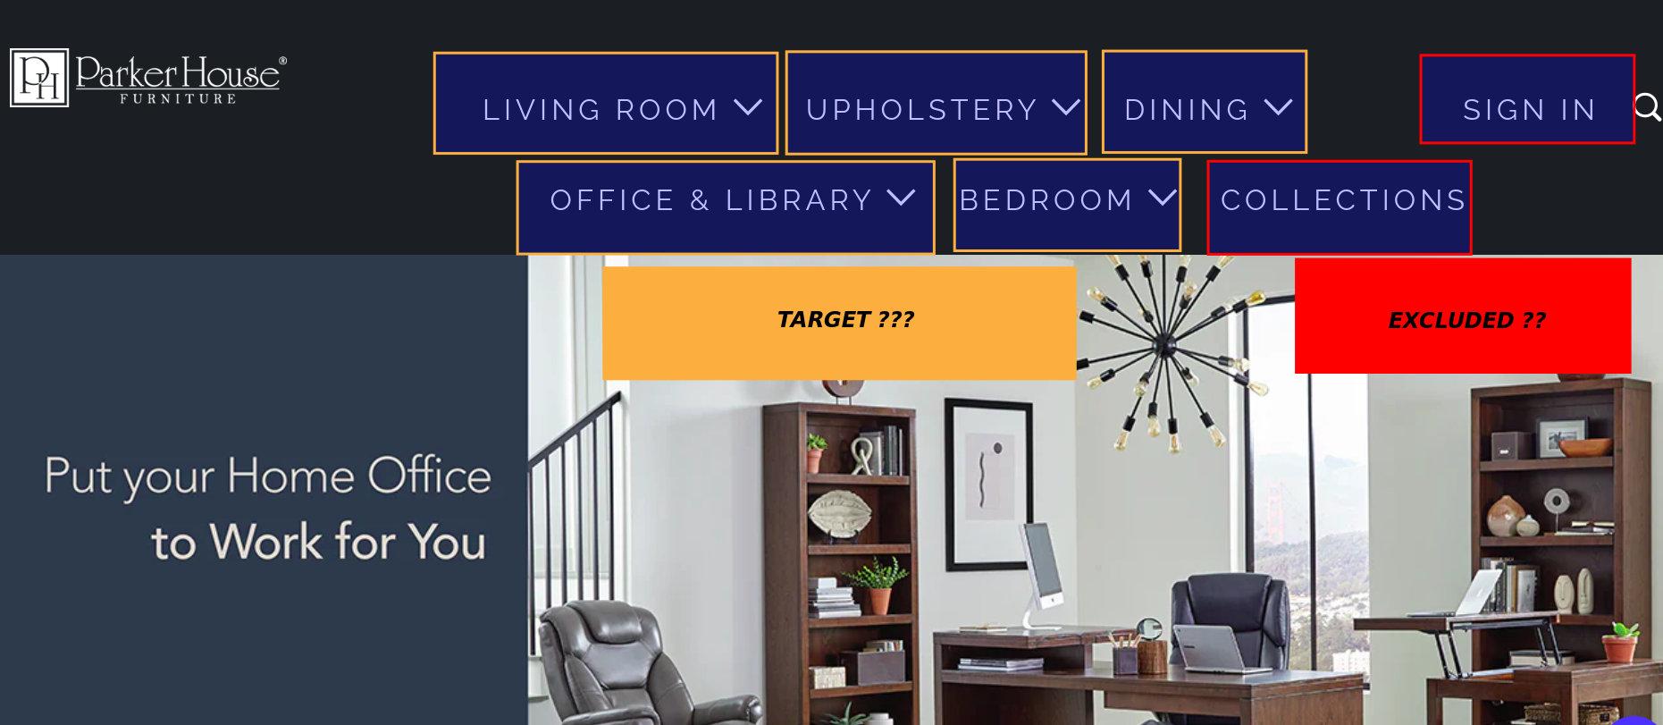

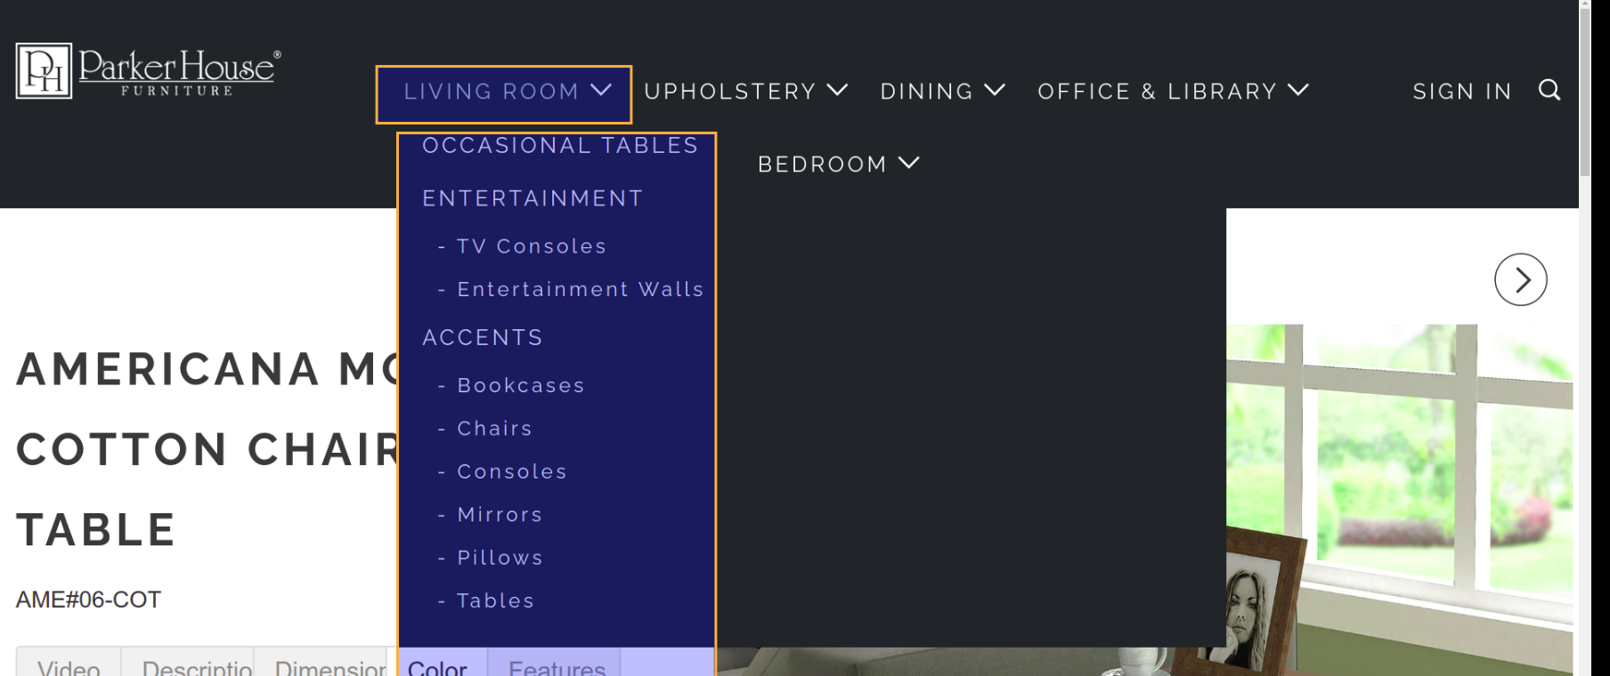

Response : Yes, pull all values for Living Room.

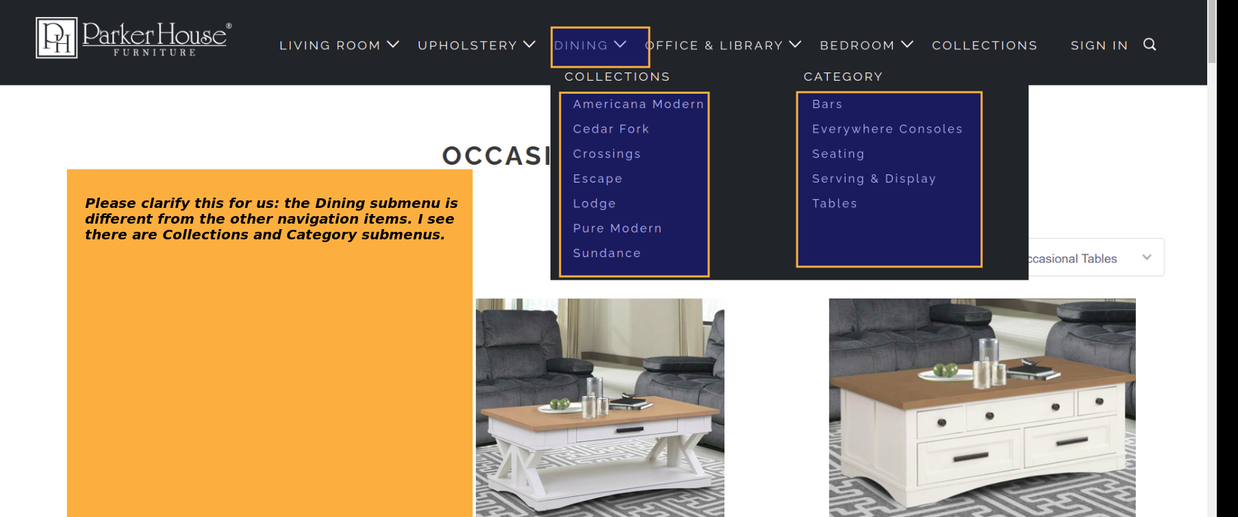

Response : For Dining, no need to pull Collections, as items appear to be available under Category values. Pull Category values only. Also, exclude Collections in the top nav menu.

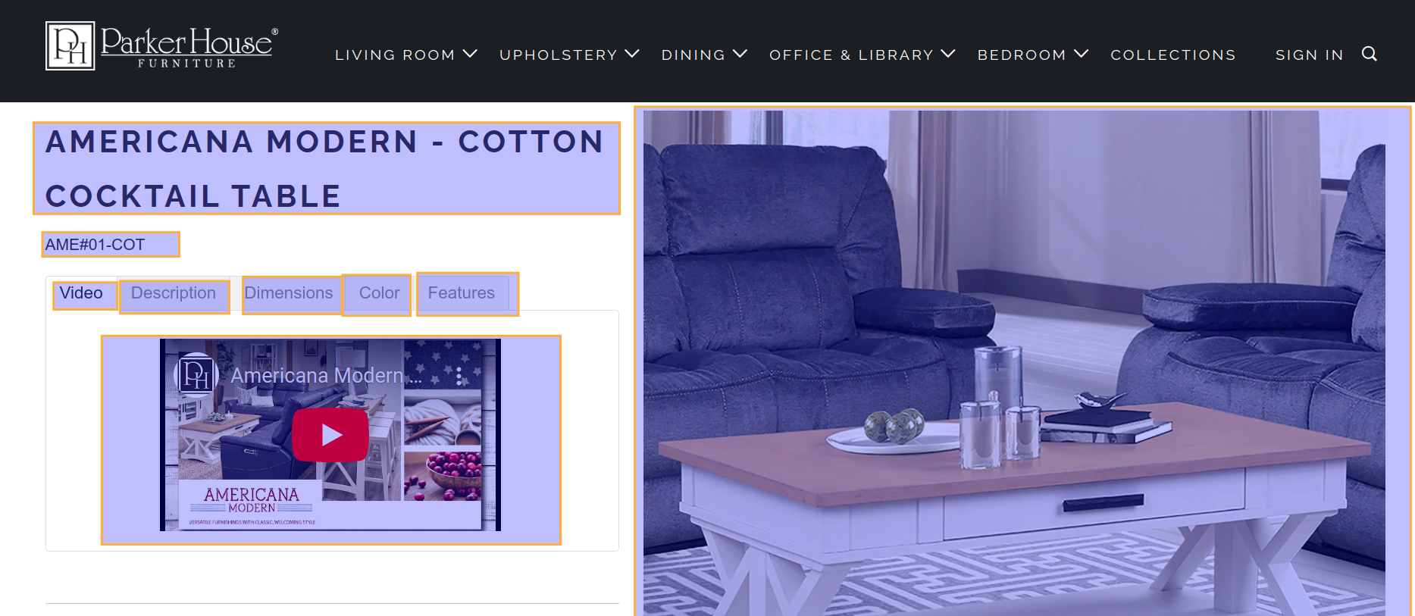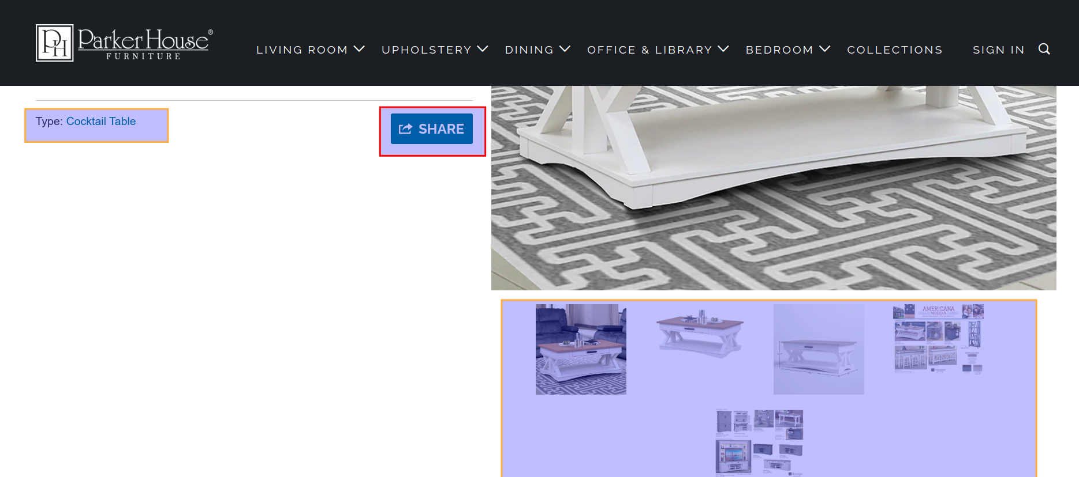

Please confirm if the marked data is correct (in yellow), that we need, and also confirm/clear about the data marked in red color.

Response : Yes, pull content highlighted in yellow, all with the exception of the Video, we can exclude the video for items. Also, exclude the Share button in red as well as Type: Cocktail Table as this appears to be a link and included in the header description.

Also, in comparing the data to the existing catalog, I do see that the # has been removed from the sku names. I think as long as you pull the info, Matthew can manipulate this piece via the automated set up.